**Online registration for the *Computing Topup Program January 2023 Intake* at *Greenwich Vietnam – Danang* *Campus* closes on *February 28th, 2022*.**

To complete online registration, please follow the procedure below:

Please can you check your Spam/Junk email folders for the invitation to register emails that were sent to you.

Once you have checked that the emails have been received, you need to log into the Portal with the username and password as shown below:

1. Log on to [www.gre.ac.uk](http://www.gre.ac.uk) and click on the word Portal highlighted in blue at the top right-hand side of the screen.



Then enter your username and password from your invitation to register emails on the right hand side of the screen.



1. Once you have logged in, at the **bottom left of the home page**, you will find the picture below which you must click on to take you to the online registration page.



1. Follow any steps that appear on screen

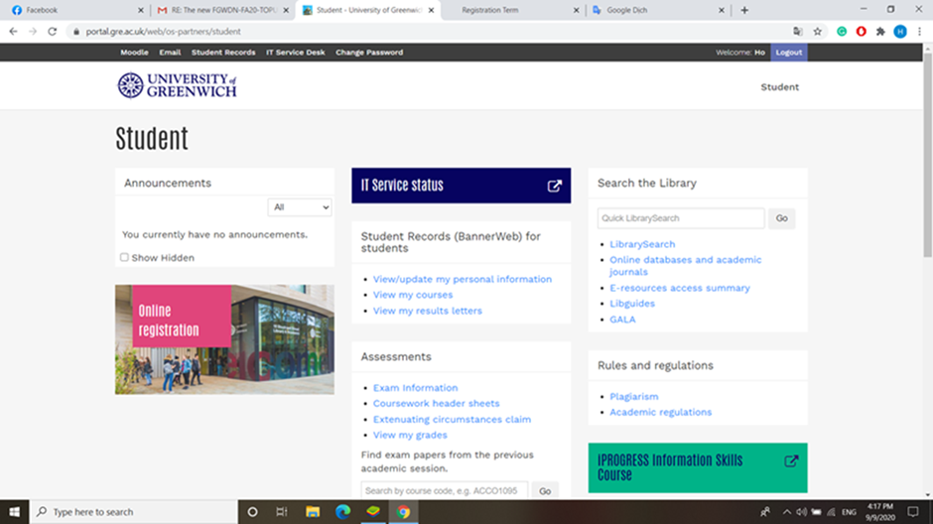

1. Please choose course code COMP1786 at article 3 and COMP1640 at article 4 when you see a screen like below:

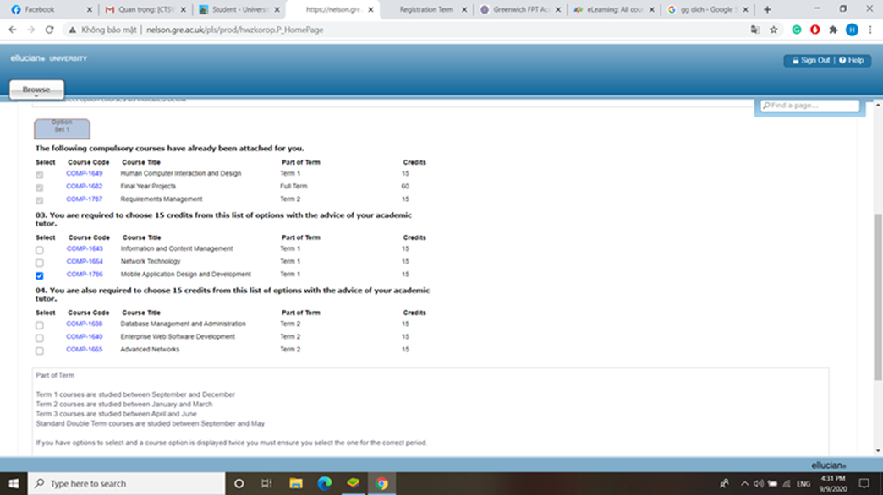

If there are any issues, it is very important that you email: [ach-collab@gre.ac.uk](mailto:ach-collab@gre.ac.uk) straight away, as **the final date for Online Registrations is []**

It would be very helpful if you can send a screenshot of any issues you are having with the registration process.